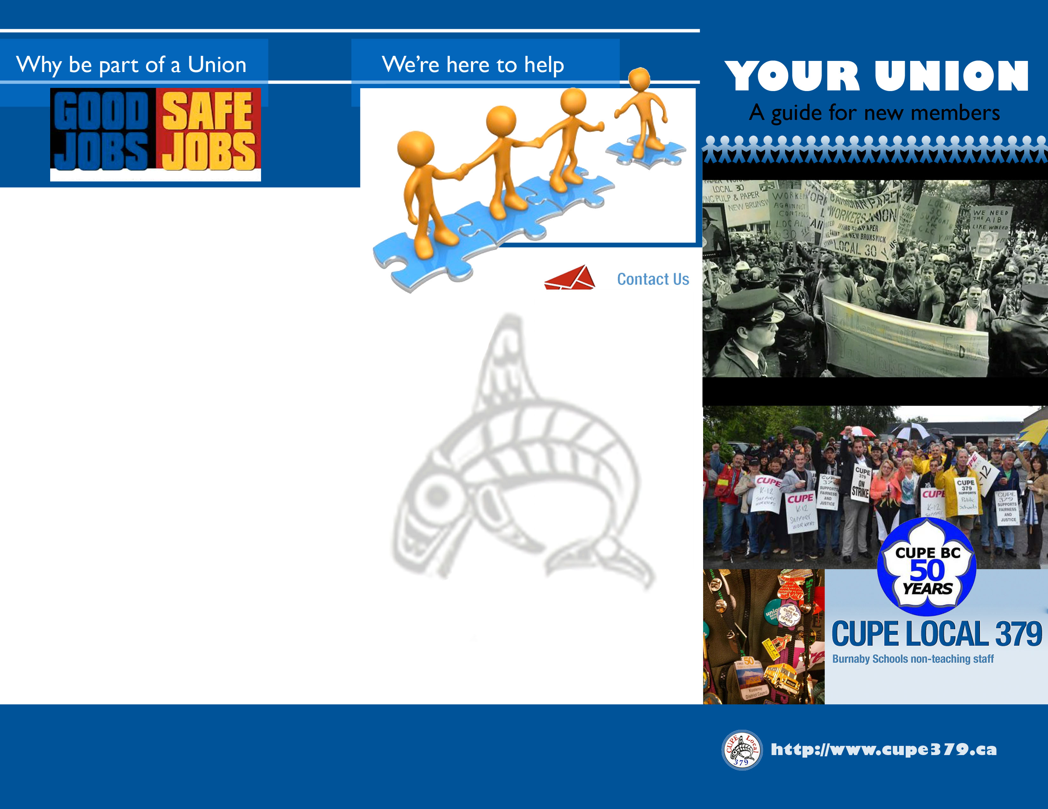
COLLECTIVE BARGAINING WORKS
Through collective bargaining we get results for workers

If you require a Shop Steward
Please contact the Union office at
(604) 257-4700 or
Cupe379@telus.net
Meet Your Executive
Decent wages
Safer working conditions
Medical, dental, and vision benefits
Protection from harassment
Parental leave
Third party care and bereavement leave
Pension and retirement benefits
Long term disability
Vacation
Sick Leave
OUR GAINS BENEFIT ALL WORKERS
Every gain unions make raises the standards for all workers. New gains happen every day.
UNIONS HELP PEOPLE EVERYWHERE
Unions help create positive change. We advocate for new and better services
The Canada Pension Plan and Old Age Security
Human rights laws
Quality Public services such as education, health care, and child care
Services in support of healthy communities such as waste management, clean water, public health and social services
Employment insurance and other support for workers
OUR ABILITY TO MAKE THESE GAINS IS THREATENED
Some politicians want to undermine your ability to bargain collectively by taking away your union’s right to collect dues from all members, or by stopping us from taking political action. Our action helps create laws that benefit working people, and if the politicians succeed, every working person would lose.
Chief Shop Steward – Michael Vanderlans
Custodial – Drew Parris & Alex Quenano
Maintenance Department – Richard Tonn
Grounds/I.T. – Michael Vanderlans

Direct Student Support – Dorothy Lenaghan, Nicole Braun & Erin Akers
Clerical – Susan Hajek & Sharlene Desbiens

If you have any questions please feel free to contact the CUPE 379 office.

Hours
8am-2pm Monday to Friday

ADDRESS –
102 – 4268 Lozells Avenue,
Burnaby, BC, V5A 0C6

Telephone
(604) 257-4700

Email
Office@cupe379.ca
- President:
Paul Simpson
- Vice President
Tommy Fagan
Treasurer:
Simi Hundle
- Recording Secretary:
Patti Tonks
- Member at Large:

Shop Stewards Listing
- Health and safety laws
- Parental leave
- Basic employment standards
- Pay equity
- Same-sex benefits
- The 8-hour day and weekend
- Minimum wages
- Vacation standards and statutory holidays
- Anti-harassment laws
- A voice in your workplace
Sergeant at Arms – Jamie Harsch
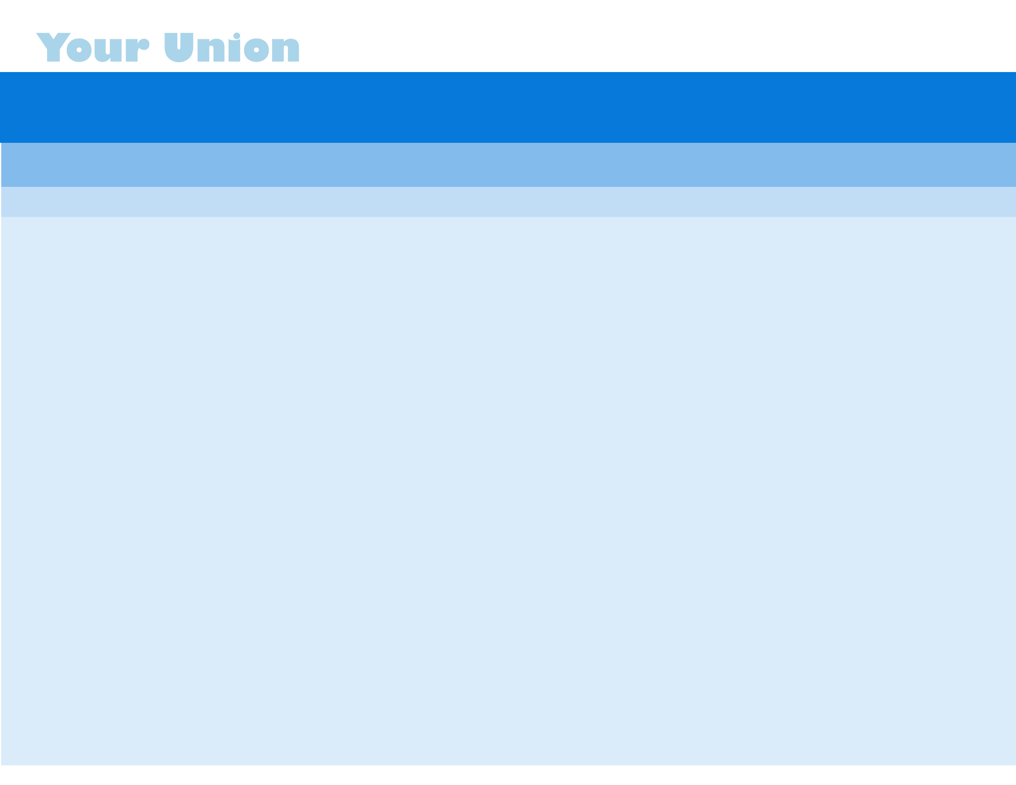

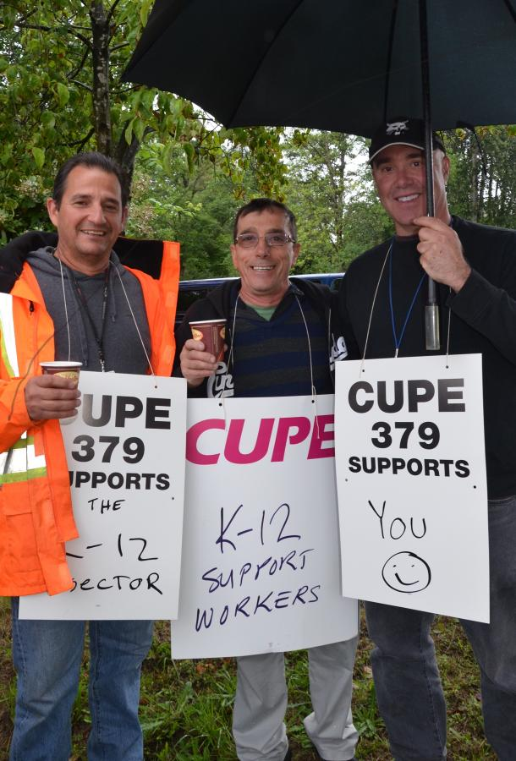
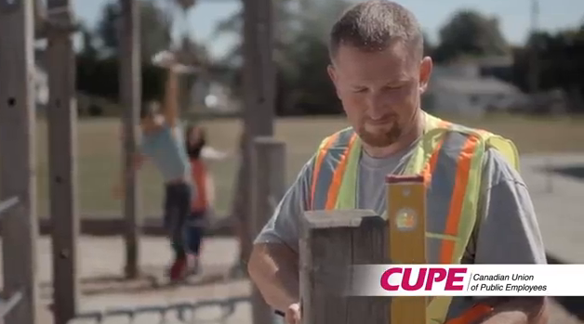
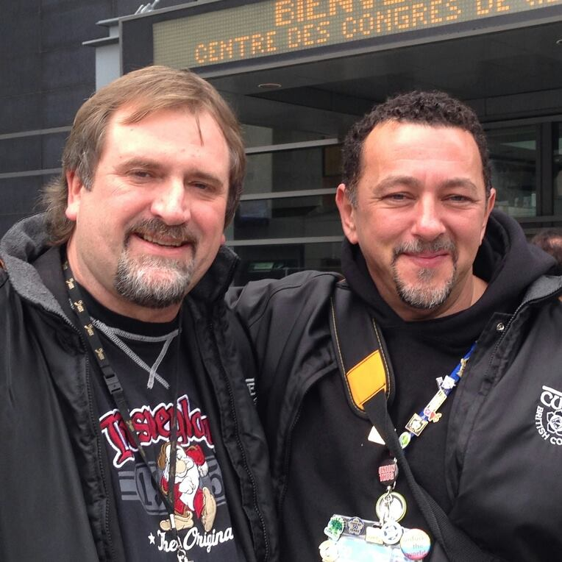
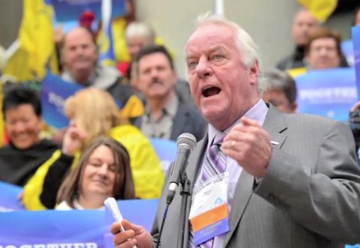

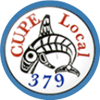
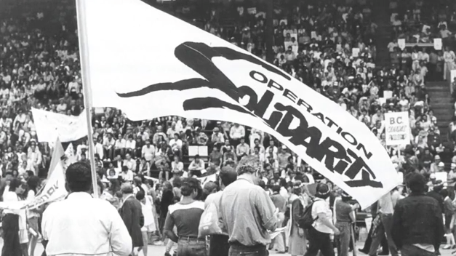
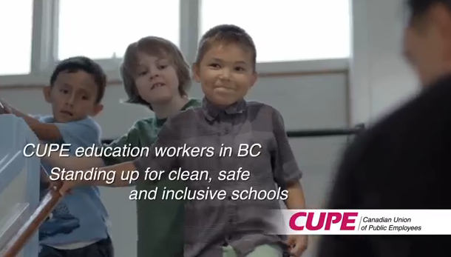


As any member of a union your Collective Agreement is the most important thing to understand. A Collective Agreement or Collective Bargaining Agreement (CBA) is an agreement between employers and employees which regulates the terms and conditions of employees in their workplace, their duties and the duties of the employer. It is usually the result of a process of collective bargaining between an employer (or a number of employers) and a union representing workers (that’s you.) The terms and conditions in your Collective Agreement outline everything from vacation, sick time, seniority, bumping rights, hours of work, rates of pay, safe work practices human rights and many others. This agreement is a legally binding document and employer and employee are both obligated to abide by it. You are entitled to all the terms and conditions outlined in your agreement, although the interpretation of the wording can sometimes be contested.

Collective
Agreement
Shop Stewards

A union representative, union steward or shop steward is an employee of an organization or company, who volunteers to represent and defend the interests of his/her fellow employees. These positions are obtained through democratic elections by the workers. They hold these positions in conjunction with their board position. They are an integral link between the union, yourself and the employer.

Shop stewards roles include

-monitor and enforce the provisions of the collective agreement to ensure both the employer and employee are upholding the terms of the agreement
-ensure that the employer is in compliance with all federal, provincial and local laws and regulations
-represent and defend fellow workers who the employer believes violated the terms of the agreement
-communicate and disseminate official union business to brothers and sisters in the workplace
-popularize and promote union consciousness and values in the workplace

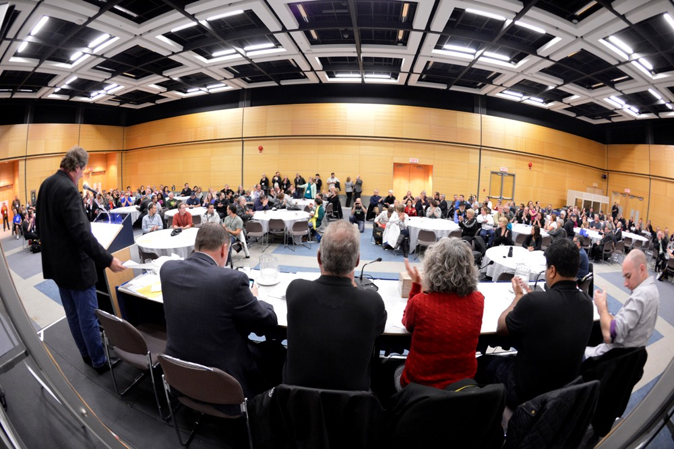

-Founded March 14th, 1950
-Founding member of CUPE on Sept. 24th, 1963
-Has a rich history in the labour movement
-Is a strong advocate for workers’ rights
-Has been instrumental in creating and leading the K-12
Provincial Bargaining Council

Your Role in Local 379

-Show up, Monthly meetings are held on the second Saturday of the month, from Sept.–June (check website at cupe379.ca)

-Speak up, Ask questions and present motions to be discussed and voted on

-Get Involved, Register for union education, attend affiliates meetings (CUPE Metro, New West District Labour Council), attend sponsored political functions, run for a position on the union executive board or one of the various committees

-Advocate, Let your fellow brothers and sisters know that CUPE 379 stands up for YOU.

*cope378
Your local, CUPE 379

